Title of your paper
First Author · Second Author · Third Author · Last Author

Abstract The abstract should summarize the content of the paper, indicating its aim, starting point, original contribution and conclusions (up to 200 words).
- Introduction
This document briefly describes how to write a manuscript for ELECTRIMACS 2022 Nancy conference.

- How to prepare your paper
  - Templates
Authors are kindly invited to prepare a manuscript according to the LATEX or Word template available on the conference website:

https://electrimacs2021.sciencesconf.org/.

The use of LaTeX is highly recommended for manuscript preparation.
This is the template version 1.0 – October 2018.
  - Manuscript information
Authors are kindly asked to prepare their manuscript according to the following specifications:
- Language: English
- Size: A4
- Two columns
- Length: from four (4) to six (6) pages.

  - Document style and size
F. Author · T. Author
LEMTA – Université de Lorraine
54505 Vandoeuvre-lès-Nancy, France
E-mail: fauthor@somewhere.org, tauthor@elsewhere.com

S. Author · L. Author
Institution name
address line 1
address line 2
City, Province, Country
email(s)

The document margin and column size are summarised in Tab. 1. Font, style and size of titles and texts are reported in Tab. 2.

Table 1 Columns and margins
Parameter | Value
Left margin | 15 mm
Right margin | 21 mm
Upper margin | 30 mm
Lower margin | 31 mm
First page upper margin | 47 mm
Blank space after author’s line | 43 mm
Column width | 84 mm
Column separation | 6 mm
Figure width | ≤84 mm

  - Submission of papers
A camera-ready PDF manuscript must be submitted for review through the conference submission system. No other file format is accepted for this initial submission. You will find more information about initial submission on the conference website Papers > Submission.

Table 2 Document Style
Style | Characteristics
Paper Title | 16 pt, bold, left-aligned
Author’s names | 10 pt, bold, left-aligned
Affiliation and e-mail | 8.5 pt, left-aligned in the  footnote in column one
Section title | 10 pt, bold, left-aligned, hierarchically numbered
Subsection title | 10 pt, italic, left-aligned, hierarchically numbered
Main body text | 10 pt, justified, single-spaced
Acknowledgements section title | 8.5 pt, bold
Acknowledgements body text | 8.5 pt, justified
Figure and table title | 8.5 pt, bold
Figure and table captions | 8.5 pt, justified

  - Figure, tables, citations and cross reference

Fig. 1 Please write the caption here. If the caption is long, the text of the caption is justified.

Refer to a figure using Fig. 1, or Fig. 2. Refer to a table using Tab. 1. You can cite an item listed in the Reference section as [1] or [2,3].

  - Equations
Equations are left-aligned and numbered as shown below:
$$\left(\frac{R_{e}}{1-D}+\frac{{DT}_{s}}{C_{e}}\right)≤∆v_{pp}^{max}.$$ | (1)

Please refer to an equation using (1).

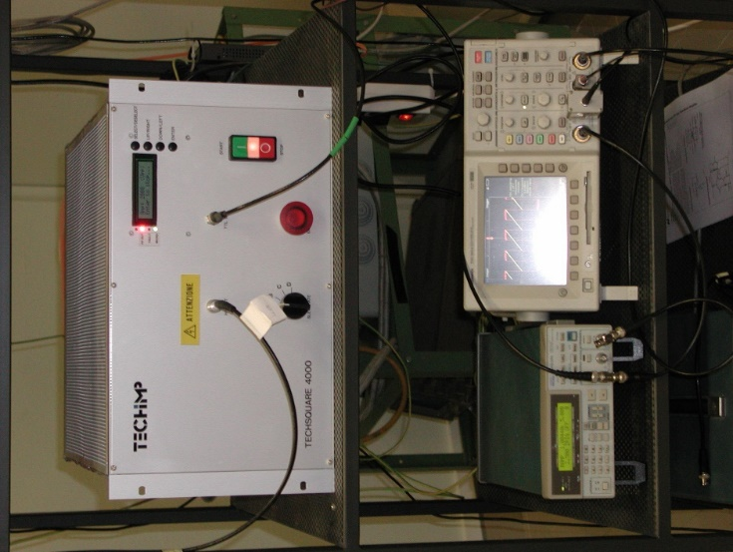
Fig. 2 Experimental setup (Please write your caption here)
- Section title
ELECTRIMACS 2022 is an international conference on theory and application of modelling, simulation, analysis, design optimization, identification and diagnostics in electrical power engineering.

  - Subsection title
Application of interest include, but are not limited to:
- electric machines and electromagnetic devices
- power electronics
- transportation systems
- smart grids
- electric and hybrid vehicles
- renewable energy systems
- energy storage, batteries, supercapacitors
wireless power transfer

- ELECTRIMACS 2022 Topics
  - Modelling and simulation of power electronics systems
- Analysis, Emerging materials/Components for power electronics converters
- Electromagnetic compatibility
- Sensors for power electronics converters
- Design and optimisation of power electronics converters
  - Modelling and simulation of electrical machines and electromagnetic device
- Modeling and simulation of electrical machines,
- Modeling and simulation of electromagnetic devices
- Analytic models in electromagnetic devices
  - Control and power management of electrical systems
- Real time simulation methods
- Modeling and control methods applied to electrical systems
- Hardware in the loop emulation of electrical systems
- Fuel cell systems
- Identification/diagnostic/prognostic techniques applied to electrical systems
  - Microgrids/smart grids
- Centralised, decentralised and distributed control of microgrids
- Design and optimisation of microgrids systems
- Optimized Power management of microgrids systems
- Forcasting methods
- Conclusions
Write your conclusions here.
Acknowledgements You can write your acknowledgements here, if necessary.

References
- W. Teulings, J.L. Schanen, J. Roudet, “Analysis of the Current Distribution Between Paralleled Capacitors in a Chopper on Printed Circuit Board”,IEEE Industry Applications Society Annual Meeting New Orleans,pp. 1066-72, 1997.
- S. Maniktala, Switching Power Supplies A to Z – Second Edition, Waltham, 2012.
- R. Cousseau and N. Patin and C. Forgez and E. Monmasson and L. Idkhajine,“Improved electrical model of aluminium electrolytic capacitor with anomalous diffusion for health monitoring”, Mathematics and Computers in Simulation, Vol. 131, pp. 268–282, 2017

